

Year 2 Home and In School Learning

**Wider curriculum - London**

**Art – visual effects**

This week we are going to have a go at creating a silhouette picture of the London skyline now we know a little more about the things we can see there! There are some images attached below this planning sheet for you to have a look at. We understand that some of you will have access to paints. Some may not. If you do not, have a go at creating a skyline with black felt tip or biro like the one above and the ones attached below. Mark out your skyline in pencil first before you use pen! If you have some paint, there is a link below to teach you how to create a ‘wash’ for a back ground before you create your skyline. Again, there are ‘wash’ examples attached below! Make your pictures as simple or as detailed as you would like!

<https://www.youtube.com/watch?v=7CkFl0zcP0M>

**PE**

Joe Wicks is now doing PE with Joe three times a week! Log on to his you tube challenge live or watch it back to carry it out later on in the day. Not only will it keep you fit but it will keep you healthy in your mind as well!

**To go alongside our English text we will continue our wider curriculum tasks about London!**

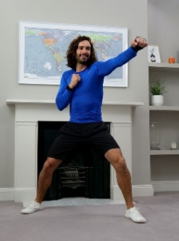



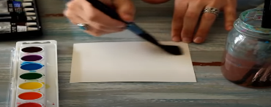

**Key learning area:**

**PE** – General fitness – get your heart rate up and build up your muscles!

**Art** – visual effects

**Geography** – To find out about the culture and landmarks of the capital city

Identify areas of interest to tourists and create a poster or a short video!

**Geography: Culture and landmarks**

Let’s do some finding out!

We have attached some information **powerpoints** for you to have a look at! Below are some extra links that give you a real feel for what London is like!

<https://www.youtube.com/watch?v=MuDAUa0XSHI>

<https://www.youtube.com/watch?v=MHxSq4c_E6g>

<https://www.youtube.com/watch?v=r90yQdsYm5k>

**Geography**

If you were a tourist in London what would you find most interesting? Create a poster that includes some of those things! You can add captions, labels or any writing if you wish!

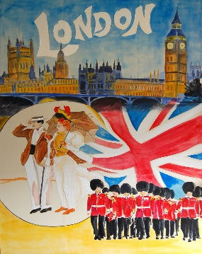

Remember to share anything you have done on SeeSaw!

