**Monday**

**Watch the video on seesaw to listen to the story.**

Alternatively, you can meet the author and listen to the story here: [**https://www.youtube.com/watch?app=desktop&v=a096Lgo7qXM**](https://www.youtube.com/watch?app=desktop&v=a096Lgo7qXM)

**Thursday**

At the beginning of the story Brenda tries very hard to fit in and be like the other sheep but it doesn’t always go well, does it?

Use the thought bubble template below to write what you think Brenda might be thinking when she is eating the grass and then when she is not very good at tag.

Here’s an example……..

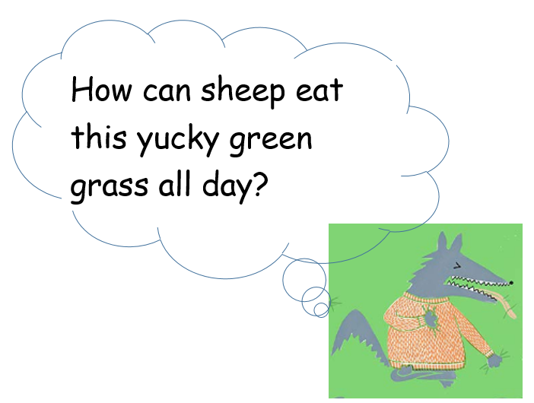

Year 1 Home and In School Learning

**English- w/c 18.01.21**

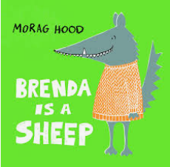

**Tuesday**

Think about the character of Brenda in the story. Use the template below (or draw your own outline) to create a Role on the Wall for Brenda. Use it to show us what you know about her appearance (what she **looks** like) and her personality (what she’s like). There are lots of clues in the book to help you.

Have a look at the clip on Seesaw to get some ideas for your Role on the Wall.

Don’t forget to upload a copy of your finished work on Seesaw! You may also want to video yourself talking about your work.

**Challenge:** Can you think of any other stories/fairy tales that have wolves in them? Make a list of them and upload it to Seesaw.

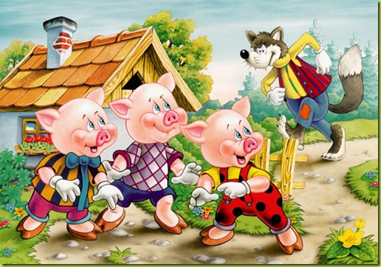

Here’s a clue to get you started!

We are going to carry on this week looking at books nominated for The Hampshire Picture Book awards 2021. This week, the story is ‘Brenda is a Sheep’ by Morag Hood

Don’t forget to fill out the voting slip at the end of the week to let us know what you thought about the book.

**Friday**

Use the voting slip (set as an activity on seesaw) to submit your vote for Brenda is a Sheep. You can give the style, story and stretch a score out of ten (10 being the best).

**Key objectives**

* express opinions about main events and characters in stories
* Write a simple sentence- compose a sentence orally before writing it, and re-read what is written to check it makes sense
* To use capital letters, finger spaces and full stops in my writing.

Remember to share anything you have done on SeeSaw!

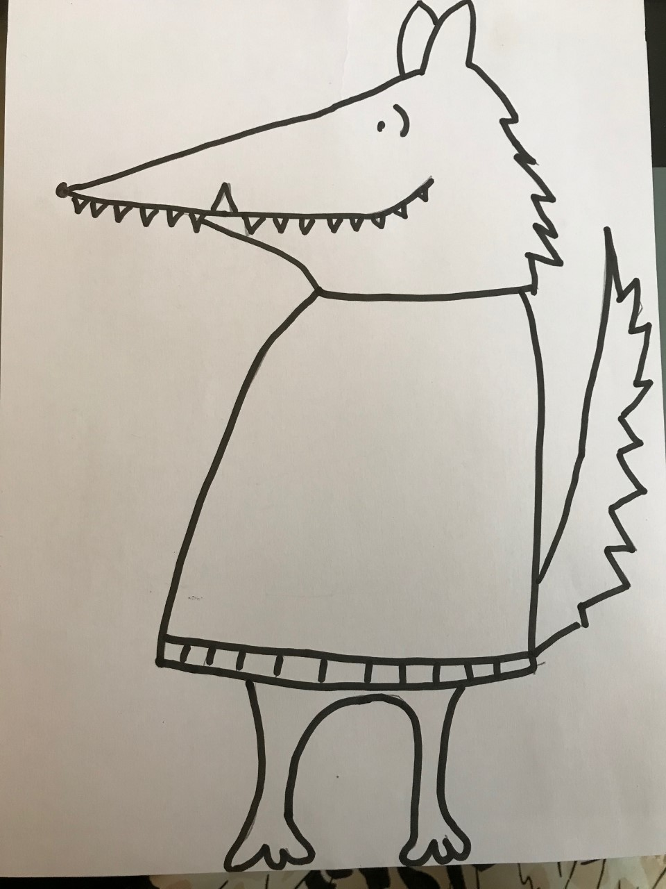Role On the Wall - Brenda



